Student name: Student ID

Week 4: In-Lecture Exercise:

Given the following directed graph and the weights of their edges

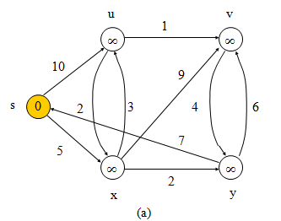

Use Dijkstra’s algorithm to find the shortest path from s to . v. Backtracking is required:

**Solution**:

S u v x y

0/NIL ∞/NIL ∞/NIL ∞/NIL ∞/NIL

Back tracking: